 | Jatiya Kabi Kazi Nazrul Islam University  Dept. of Human Resource Management  MBA Weekend Program  Session: Summer-2024 (Business) 2nd Semester  and Summer-2023 (Non-Business) 4th Semester

SL. |  | Student Details |  | Educational Details | Picture
01.
  Name | : | Jhuma Akter Poly
  ID No | : | 241327101
  Father | : | MD Tara Mia
  Mother | : | Maleka Akter
  Mobile | : | 01758172517
  Current Status | : | Student
  Organization | : | Jatiya Kabi Kazi Nazrul Islam University
  Honours Ins. | : | College of Business Science and Technology
  College Name | : | Mohangonj Mohila College, Netrokona
  Upazila/District | : | Mohongonj | Netrokona
  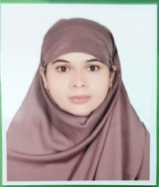
02.
  Name | : | Ali Hasan Khan Roky
  ID No | : | 241327102
  Father | : | Ayeub khan
  Mother | : | Rokeya Khatun
  Mobile | : | 01324-613931
  Current Status | : | Executive, Team: Aalo
  Organization | : | Soft BD Limited
  Honours Ins. | : | Ishakha International University, Kishoreganj
  College Name | :
  Upazila/District | : | Netrakona Sadar | Netrakona
  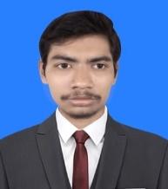
03.
  Name | : | Md. Taufike Rahman
  ID No | : | 241327103
  Father | : | Md. Moniruzzaman
  Mother | : | Rahana Khanam
  Mobile | : | 01777576430
  Current Status | : | Student
  Organization | : | Jatiya Kabi Kazi Nazrul Islam University
  Honours Ins. | : | Uttara University, Dhaka
  College Name | : | Ananda Mohan College, Mymensingh
  Upazila/District | : | Mymensingh Sadar | Mymensingh.
  
04.
  Name | : | Ismat Begum Papia
  ID No | : | 241327104
  Father | : | A.k.M. abul Munshur
  Mother | : | Umme Roushon
  Mobile | : | 01795787961
  Current Status | : | Student
  Organization | : | Jatiya Kabi Kazi Nazrul Islam University
  Honours Ins. | : | Anando Mohan College
  College Name | : | Trishal Mohila College
  Upazila/District | : | Trishal | Mymensingh
  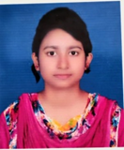
05.
  Name | : | Preeom Sarker
  ID No | : | 241327106
  Father | : | Ronjon Kumer Sarker
  Mother | : | Eti Sarker
  Mobile | : | 01752824604
  Current Status | : | Student
  Organization | : | Jatiya Kabi Kazi Nazrul Islam University
  Honours Ins. | : | Govt. Titumir College
  College Name | : | Shahid syed Nazrul Islam College,Mymensingh
  Upazila/District | : | Mymensingh Sadar | Mymensingh
  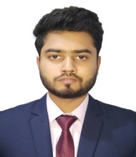
Jatiya Kabi Kazi Nazrul Islam University
Dept. of Human Resource Management
MBA Weekend Program
Session: Summer-2024 (Business) 2nd Semester
and Summer-2023 (Non-Business) 4th Semester

SL. |  | Student Details |  | Educational Details | Picture
06.
  Name | : | Md Furhad Ullah Sohag
  ID No | : | 241327107
  Father | : | Md Ansar Ali
  Mother | : | Mist Bina Parvin
  Mobile | : | 01982204520
  Current Status | : | Student
  Organization | : | Jatiya Kabi Kazi Nazrul Islam University
  Honours Ins. | : | College of Business Science & Technology
  College Name | : | Lalmonirhat government College
  Upazila/District | : |  | Jamalpur
  
07.
  Name | : | Arup Dey
  ID No | : | 241327108
  Father | : | Akhil Chandra Dey
  Mother | : | Basona Rani Dey
  Mobile | : | 01716854148
  Current Status | : | Student
  Organization | : | Jatiya Kabi Kazi Nazrul Islam University
  Honours Ins. | : | Govt. Titumir College
  College Name | : | Shahid Syed Nazrul Islam College, Mymensingh
  Upazila/District | : | Mymensingh
  
08.
  Name | : | Romana Akter Ria
  ID No | : | 241327109
  Father | : | Md. Abdur Rashid
  Mother | : | Fatema Khatun
  Mobile | : | 01798498735
  Current Status | : | Executive, (HR, Admin & compliance)
  Organization | : | Square Denims limited
  Honours Ins. | : | Nasirabad University College, Mymensingh
  College Name | : | Mymensingh Government College
  Upazila/District | : | Mymensingh Sadar | Mymensingh
  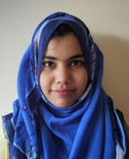
09.
  Name | : | Muhammad Nazmul Ahasan
  ID No | : | 241327110
  Father | : | MD Ayub Uddin
  Mother | : | Nasrin Begum
  Mobile | : | 01911559599
  Current Status | : | Student
  Organization | : | Jatiya Kabi Kazi Nazrul Islam University
  Honours Ins. | : | American International University Bangladesh
  College Name | :
  Upazila/District | : | Mymensingh Sadar | Mymensingh
  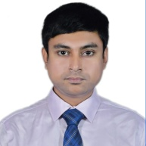
10.
  Name | : | Noushin Jahan Nowshin
  ID No | : | 241327111
  Father | : | Najmul Kabir Niru
  Mother | : | Nargis Jahan Shahin
  Mobile | : | 01745784957
  Current Status | : | Student
  Organization | : | Jatiya Kabi Kazi Nazrul Islam University
  Honours Ins. | : | Shanto Mariam University of Creative Technology
  College Name | : | Govt. Zaheda Safir Mohila College, Jamalpur
  Upazila/District | : | Sherpur Sadar | Sherpur
  
Jatiya Kabi Kazi Nazrul Islam University
Dept. of Human Resource Management
MBA Weekend Program
Session: Summer-2024 (Business) 2nd Semester
and Summer-2023 (Non-Business) 4th Semester

SL. |  | Student Details |  | Educational Details | Picture
11.
  Name | : | Sabrina Muhtarin Tazim
  ID No | : | 241327112
  Father | : | A.K.M Shafiqul Islam
  Mother | : | Fauzia Islam
  Mobile | : | 01932395553
  Current Status | : | Student
  Organization | : | Jatiya Kabi Kazi Nazrul Islam University
  Honours Ins. | : | Independent University Bangladesh
  College Name | : | Sylhet Govt. Women's College, Sylhet
  Upazila/District | : | Mymensingh Sadar | Mymensingh
  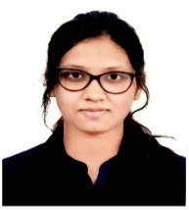
12.
  Name | : | Sabbir Ahmed Shaikot
  ID No | : | 231327301
  Father | : | Mottalib Darbari
  Mother | : | Shorfun Nahar
  Mobile | : | 01974161014
  Current Status | : | Business
  Organization | : | Camera Ghar
  Honours Ins. | : | Jatiya Kabi Kazi Nazrul Islam University
  College Name | : | Notre Dame College Mymensingh
  Upazila/District | : | Fulbaria | Mymensingh
  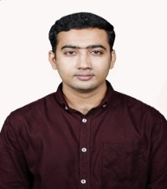
13.
  Name | : | Md. Shahinur Millat Azad
  ID No | : | 231327302
  Father | : | Md. Abdur Razzak
  Mother | : | Shamsunnahar
  Mobile | : | 01997491776
  Current Status | : | Student
  Organization | : | Jatiya Kabi Kazi Nazrul Islam University
  Honours Ins. | : | Port City international university
  College Name | : | B. N. School and college
  Upazila/District | : | Haluaghat | Mymensingh
  
14.
  Name | : | Arifur Rahman
  ID No | : | 231327303
  Father | : | Late. Abdur Rahman
  Mother | : | Hosneara Begum
  Mobile | : | 01776362252
  Current Status | : | Admin supervisor
  Organization | : | Social Marketing Company (SMC)
  Honours Ins. | : | Govt. Titumir College, Dhaka
  College Name | : | Tamirul Millat kamil Madrasha, tongi, Gazipur
  Upazila/District | : | Monohargong,Cumilla
  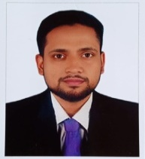
15.
  Name | : | Md.Moinul Hoque
  ID No | : | 231327304
  Father | : | Late Musleh Uddin Dali
  Mother | : | Mrs.Delara Begum
  Mobile | : | 01713187162
  Current Status | : | Section In-Charge (Accounts & Admin)
  Organization | : | Delta Pharma Ltd. ( Plant Division)
  Honours Ins. | : | Gafargaon University College
  College Name | : | Gafargaon Govt. College
  Upazila/District | : | Gafargaon | Mymensingh
  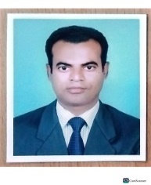
Jatiya Kabi Kazi Nazrul Islam University
Dept. of Human Resource Management
MBA Weekend Program
Session: Summer-2024 (Business) 2nd Semester
and Summer-2023 (Non-Business) 4th Semester

SL. | Student Details | Educational Details | Picture
16.
  Name | : | Saiful Hoque
  ID No | : | 231327305
  Father | : | Md. Aminul Hoque
  Mother | : | Nasrin Begum
  Mobile | : | 01744717540
  Current Status | : | Executive (HR & Admin)
  Organization | : | Fakhruddin Textile Mills Ltd. (Urmi Group)
  Honours Ins. | : | Mawlana Bhashani Science and Technology University
  College Name | : | Rajendrapur Cantonment Public School and College
  Upazila/District | : | Gazipur Sadar | Gazipur
  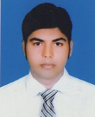
17.
  Name | : | Nazmul Haque
  ID No | : | 231327306
  Father | : | Abdul Hamid
  Mother | : | NASIMA
  Mobile | : | 01917065885
  Current Status | : | Assistant HR Manager
  Organization | : | Fakhruddin Textile Mills Limited (Urmi Group)
  Honours Ins. | : | Bhawal Badre Alam Government College
  College Name | : | Bhawal Badre Alam Government College
  Upazila/District | : | Sreepur | Gazipur
  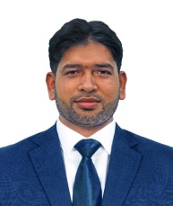

Alumni Student Details Information

Md. Al-Amin (Sajib)
Assistant Program Director
Assistant Professor, Dept. of HRM
MBA weekend Program, JKKNIU

